Handwritten Digit Recognition

Submitted in partial fulfilment of the requirements

For the subject of

Mini Project

By

Jotiba Prakash Yadav  
(Roll No.61)

Venkatesh Ganeshan

(Roll No.56)

Rushikesh Darge

(Roll No.08)

Under the Supervision of

**Prof. A. D. Palsodkar**



DEPARTMENT OF INFORMATION TECHNOLOGY

KONKAN GYANPEETH COLLEGE OF ENGINEERING

KARJAT-410201

December 2020

# Certiﬁcate

This is to certify that the project entitled **Handwritten Digit Recognition** is a bonaﬁde work of **Jotiba Yadav (Roll No.61), Venkatesh Ganeshan (Roll no.56), Rushikesh Darge (Roll no.08)**, submitted to the Department of Information Technology in partial fullerene of the Mini Project.

**Supervisor/Guide Head of Department**

**Professor Professor**

**Department of Information Technology Department of Information Technology**

Project Report Approval

This project report entitled **Handwritten Digit Recognition** by, **Jotiba Yadav(Roll No:62), Venkatesh Ganeshan (Roll No:57),Rushikesh Darge (Roll No:08)** is approved for the partial fulﬁllment of the requirement for the subject of MiniProject.

**Examiners**

1………………………………………

2………………………………………

**Date:**

**Place:**

# Declaration

We declare that this written submission represents our ideas in our own words and where others’ ideas or words have been included, we have adequately cited and referenced the original sources. We also declare that I have adhered to all principles of academic honesty and integrity and have not misrepresented or fabricated or falsiﬁed any idea/data /fact/source in our submission. We understand that any violation of the above will be cause for disciplinary action by the Institute and can also evoke penal action from the sources which have thus not been properly cited or from whom proper permission has not been taken when needed.

**Signature**

**Jotiba Prakash Yadav (Roll No.61)**

**Signature**

**Venkatesh Ganeshan (Roll No.56)**

**Signature**

**Rushikesh Darge (Roll No.08)**

**Date:**

# Abstract

Digit recognition system is the working of a machine to train itself or recognizing the digits from different sources like emails, bank cheque, papers, images, etc. and in different real-world scenarios for online handwriting recognition on computer tablets or system, recognize number plates of vehicles, processing bank cheque amounts, numeric entries in forms filled up by hand (say — tax forms,receipts) and so on. Our goal is to create a system which detects numbers from images based on previously learned datasets.

# ACKNOWLEDGEMENTS

We would like to express our special thanks of gratitude to our teacher**(Prof. Palsodkar)**as well as our HOD Sir**( )** who gave us the golden opportunity to do this wonderful project on the topic (Handwritten Digit Recognition), which also helped us in doing a lot of research and We came to know about so many new things we are really thankful to them. Secondly we would also like to thank our parents and friends who helped us a lot in finalizing this project within the limited time frame.

Contents

Certiﬁcate 2

Declaration 4

Abstract 6

ACKNOWLEDGEMENTS 7

Abbreviations 10

INTRODUCTION 11

1.1 Introduction 11

1.2 Objectives 12

1.3 Motivation 12

1.4 Purpose, Scope, and Applicability 12

1.4.1 Purpose 12

1.4.2 Scope and Limitations 13

1.4.3 Applicability 13

LITERATURE SURVEY AND PAPER REVIEW 14

2.1 Literature Survey 14

Handwritten Digit Recognition using Adaptive Neuro-Fuzzy System and Ranked Features 14

Handwritten Arabic Numeral Recognition using Deep Learning Neural Networks 15

Effective Handwritten Digit Recognition Based on Multi-feature Extraction and Deep Analysis 16

Farsi Handwriting Digit Recognition based on Convolutional Neural Networks 16

Handwritten Digit Recognition Based on DepthNeural Network 17

Kinect-based Mid-air Handwritten Digit Recognition using Multiple Segments and Scaled Coding 17

Handwritten Digits Recognition with Artificial Neural Network 18

Design and implementation of handwritten digit recognition system based on template method 19

2.2 Paper Comparison 20

SURVEY OF METHODOLOGY 23

3.0.1 Artificial Neural Network 23

3.0.2 Computer Vision 24

3.0.3 Deep Convolutional Neural Networks 24

DEPLOYMENT 26

4.1 Streamlit…………………………………………………………………………………………………….26

4.2 Flask Framework………………………………………………………………………………………..27

4.3 Bidirectional LSTM………………………………………………………………………………………28

REQUIREMENTS AND ANALYSIS 28

5.1Problem Definition 28

5.2 Requirements Specification 28

CONCLUSIONS 30

6.1 Output………………………………………………………………………………………………………….30

6.2 Conclusion……. 30

Bibliography 31

Journals and Conferences 31

Websites 32

# 

# Abbreviations

**OCR** Optical character recognition

**SVM**  Support Vector Machine

**NN**  Neural Network

**ML**  Machine Learning

Chapter 1

# INTRODUCTION

## 1.1 Introduction

Image classification is one of the core problems of computer vision, image classification refers to the task of extracting information classes from a multiband raster image. One of the important applications of image classification is the optical character recognition (OCR). OCR is the electronic conversion of scanned images of handwritten text into machine encoded text. In Optical character recognition, an algorithm will be trained on a dataset of known characters in order to learn how to classify characters included in the test set accurately. A variety of algorithms has been developed for classifying letters and digits from the last decades. In the field of optical character recognition there are three methods: template matching, feature extraction and classification

The late 80s in order to take advantage of massive samples, classification methods such as artificial neural networks had been utilized popularly for recognition problems. In the last decade, machine learning methods such as support vector machines (SVMs) have been applied for pattern recognition problems. Neural networks (NNs) are another solution to resolve recognition problems. In this a large number of handwritten letters/digits known as training sets are fed into the algorithm in order to infer rules automatically for handwritten character recognition.

## 1.2 Objectives

In this section we mention objectives of our project:

To build a system using machine learning techniques that automatically detect handwritten digit from image. Create an efficient model that give accurate prediction of digit

## 1.3 Motivation

Computer vision and machine learning is considered as one of the challenging and growing field. Thus, makes it a topic of interest. Image processing is root of computer vision and by using machine learning techniques it is possible to improve computer vision. Many machine learning techniques are able to learn and recognize handwritten characters to a greater extent. Handwritten digit recognition is a challenging task because of its variety of handwriting style This idea motivates to work on an detect handwritten digit from image.

## 

## 1.4 Purpose, Scope, and Applicability

### 1.4.1 Purpose

#### The handwritten digit Recognitionis targeted to assign a number to the relevant input image. increase in digitalization due to reliability to convert old paper documents to digital format, at the same time store physical document is a challenge so due to this, we create a model that easily and fastly detect number we start with number as the same model and idea we use in this numbers we can easily scale this on alphabets.

##### 

### 

### 1.4.2 Scope and Limitations

The scope of this paper is handwritten digit recognition regarding the application of machine learning algorithms based on image pre-processing and feature extraction. Additionally, the purposes are not only to improve the current recognition performance, but also to seek the highest reliability in the applications of handwritten digits.

This thesis has the following limitations:

* A handwritten digit dataset is vague in essence because there may not always be perfectly straight lines, and different people’s writings are more or less sloped;
* The curves are not necessarily smooth like the printed characters;
* The recognition system sometimes shows inconsistent results due to the similarly shaped numerals;
* All handwritten digital images that are final tested do not automatically detect boundaries and cropping as well;
* The time assigned to this paper was five months. Due to the limited amount of time, the proposed model was not further optimized.

### 1.4.3 Applicability

1. Autonomous Cars
2. Handwriting recognition
3. License Plate readers for parking structures/security cameras
4. Convert handwritten text into digital docs

Chapter 2

# LITERATURE SURVEY AND PAPER REVIEW

**Literature Survey** : Is the process of analyzing, summarizing, organizing, and presenting novel conclusions from the results of technical review of a large number of recently published scholarly articles. In this chapter we survey previous research done on automatic image annotation, we have studied about following papers published by some experts

## 2.1 Literature Survey

### Handwritten Digit Recognition using Adaptive Neuro-Fuzzy System and Ranked Features

Author: Savita Ahlawat, Rahul Rishi

This paper investigates Adaptive Neuro-Fuzzy Inference System (ANFIS) for recognition of handwritten digits. First, an efficient feature extraction module based on five feature extraction techniques has been performed. Second, an optimal feature selection method for feature ranking and feature reduction has been proposed. An adaptive network is a network that consists of nodes describing parameters of input dataset and directional link through which the nodes are connected. Learning rules are selected to get final output from these parameters keeping minimization of prescribed error measure. It is basically an implementation of fuzzy logic inference system in an artificial neural network framework. The ambiguity, uncertainty, impreciseness and vagueness in the input sample are handled using Fuzzy Logic. The features are associated with each output class using membership function. Third, a classification based on ANFIS has been done. The Experiments has been performed on a standard handwritten digit dataset to evaluate the performance of the proposed system. Simulation result revels the proposed system has low testing and checking error with high recognition accuracy.

### Handwritten Arabic Numeral Recognition using Deep Learning Neural Networks

Author: Akm Ashiquzzaman, Abdul Kawsar Tushar

Handwritten character recognition is an active area of research with applications in numerous fields. Past and recent works in this field have concentrated on various languages. Arabic is one language where the scope of research is still widespread, with it being one of the most popular languages in the world and being syntactically different from other major languages. Das et al. has pioneered the research for handwritten digit recognition in Arabic. In this paper, they propose a novel algorithm based on deep learning neural networks using appropriate activation function and regularization layer, which shows significantly improved accuracy compared to the existing Arabic numeral recognition methods.

Dataset - Deep learning is solely dependent on the data and hence it needs a large amount of data to function properly. Our model is trained and tested on the CMATERDB 3.3.1 Arabic handwritten digit dataset. The entire dataset consists of 3000 images, making it a source of 3000 unique samples. they divide the dataset in the same way as Das et al. suggested in their studies, which is 2000 training samples and 1000 test samples. The proposed model gives 97.4 percent accuracy, which is the recorded highest accuracy of the dataset used in the experiment. they also propose a modification of the method described in, where our method scores identical accuracy as that of, with the value of 93.8 percent

### Effective Handwritten Digit Recognition Based on Multi-feature Extraction and Deep Analysis

Author: Caiyun Ma, Hong Zhang

This paper proposes an effective handwritten digit recognition approach based on specific multi-feature extraction and deep analysis. First, they normalize images of various sizes and stroke thickness in preprocessing to eliminate negative information and keep relevant features. Secondly, considering that handwritten digit image recognition is different from traditional image semantics recognition, they propose specific feature definitions, including structure features, distribution features and projection features. Moreover, they fuse multiple features into the deep neural networks for semantics recognition. Experiments results on benchmark database of MNIST handwritten digit images show that the performance of our algorithm is remarkable and demonstrate its superiority over several existing algorithms like Linear and Non-Linear Classifier, Support Vector Machines (SVMs), Neural Networks(NNs), Boosted Stumps, CNN-SVM Classifier, etc.

### Farsi Handwriting Digit Recognition based on Convolutional Neural Networks

Author: Atefeh Dehghanian, Vahid Ghods

In this paper, a convolutional neural network (CNN) is exploited for Farsi handwritten digit recognition. For training and evaluating the CNN, the “HODA” dataset was used which consists of 80000 images of Farsi handwritten digits. In the proposed method, they focused on the efficient and unique feature of Farsi digits that is using just the half upper part of the digits for recognition purposes. Feature extraction is the most important and effective stage in recognition rate. Features should be selected in a way for a specific class of data. They are invariant of scaling and translation or other shape transformations of the image. Also the selected features must have close values for the all samples in one class of data and have far enough values for the samples from different classes. The proposed method, despite a 50% reduction in the data size which fed to the CNN, yielded an acceptable reduction in time consuming for training and evaluate CNN of about 50 % compared when using the full image of the digits (full data), and just a 1.5% increase in recognition error. In spite of removing half of the data, accuracy rate of 97.38% was achieved.

### Handwritten Digit Recognition Based on DepthNeural Network

Author: Yawei Hou, Huailin Zhao

Neural network and depth learning have been widely used in the field of image processing. Good recognition results are often required for complex network models. But the complex network model makes training difficult and takes a long time. In order to obtain a higher recognition rate with a simple model, the BP neural network and the convolutional neural network are studied separately and verified on the MNIST data set. In order to improve the recognition results further, a combined depth network is proposed and validated on the MNIST dataset. The experimental results show that the recognition effect of the combined depth network is obviously better than that of a single network. A more accurate recognition result is achieved by the combined network. BP neural network is a multi-layer feedforward neural network. The main feature of the network is the signal forward transmission and the error back propagation. The best result of the CNN used in this paper is 99.43%. In this paper experimenting with the MNIST data set, the optimal result of the combined depth network is 99.55%. Compared with the three single network models, the recognition results are improved.

### Kinect-based Mid-air Handwritten Digit Recognition using Multiple Segments and Scaled Coding

Author: Fu-An Huang, Chung-Yen Su, Tsai-Te Chu

In this paper they presented an effective method of Kinect-based mid-air handwritten digit recognition for a potential application to TV remote controllers. The traditional human computer interaction is based on optical cameras. However, the optical camera has its limitations in the presence of variation of lighting conditions and background clutters. In 2010, Microsoft launched Kinect, which provides an RGB camera and a depth sensor. Then, in 2011, Microsoft released the Kinect Software Development Kit (SDK), including a set of powerful algorithms for extracting scene depth. With the help of the Kinect SDK, objects can be easily extracted. Therefore, the design of human-computer interaction becomes easy and the researchers can focus on their creation. However, its recognition accuracy is only about 86.7%. In this study, they propose an improved method, based on multiple segments and scaled coding. Experimental results show that the proposed method can elevate the accuracy up to 94.6%.

### Handwritten Digits Recognition with Artificial Neural Network

Author: Kh Tohidul Islam, Ghulam Mujtaba, Dr. Ram Gopal Raj, Henry Friday Nweke

In this study, they implemented a multi-layer fully connected neural network with one hidden layer for handwritten digits recognition. The testing has been conducted from publicly available MNIST handwritten database. From the MNIST database, they extracted 28,000 digits images for training and 14,000 digits images for performing the test. They implemented an artificial neural network (ANN) and trained it to recognize handwritten digits from 0 to 9. A node in a neural network can be understood as a neuron in the brain. Each node is connected to other nodes through weights which are adjusted in the machine learning process during training. A value is calculated for each node based on values and ways of previous nodes. This process is called forward propagation. The final output of the network is associated with the target output, then weights are calibrated to minimize a transgression function describing whether the network guessed correctly. This process is called back propagation. To add more complexity and accuracy in the neural networks, the networks have multiple layers. There is numerous variations exist in person to the person writing style. In a handwriting recognition system, 100% accuracy cannot be expected in practical applications. Their multi-layer artificial neural network has an accuracy of 99.60% with test performance.

### Design and implementation of handwritten digit recognition system based on template method

Author: Yang Zhiqi, Fu Kai

In this paper, the basic principles of handwritten digit recognition are introduced, including the basic principles and methods of digital image preprocessing and feature extraction using template method. Secondly, the implementation steps of handwritten digits recognition are introduced. Finally, the experimental results, analysis and conclusions are obtained. Experimental results show that this method has a high recognition rate and a good noise immunity.

Pre-processing - The binarization processing of the image is to set the gray value of the point on the image to 0 or 255 by the threshold comparison, which is to make the whole image show a clear black and white effect.

The Template Matching Method - Template matching is one of the typical methods of image recognition. It compares the eigenvalues of the extracted images with the corresponding eigenvalues of the template. By calculating the distance between the images and the eigenvalues of the template, the class is determined by the minimum distance method. Template matching requires the establishment of a standard template library.

## 2.2 Paper Comparison

|  |  |  |  |
| --- | --- | --- | --- |
| **Sr. No** | **Paper Title** | **Author** | **Description** |
| 1 | Handwritten Digit Recognition using Adaptive Neuro-Fuzzy System and Ranked Features | Savita Ahlawat Rahul Rishi | This paper investigates Adaptive Neuro-Fuzzy Inference System (ANFIS) for recognition of handwritten digits. The Experiments has been performed on standard handwritten digit dataset to evaluate the performance of the proposed system. Simulation result revels the proposed system has low testing and checking error with high recognition accuracy. |
| 2 | Handwritten Arabic Numeral Recognition using Deep Learning Neural Networks | Akm Ashiquzzaman Abdul Kawsar Tushar | The proposed model gives 97.4 percent accuracy, which is the recorded highest accuracy of the dataset used in the experiment. They also propose a modification of the method described in, where our method scores identical accuracy as that of, with the value of 93.8 percent |
| 3 | Effective Handwritten Digit Recognition Based on Multi-feature Extraction and Deep Analysis | Caiyun Ma Hong Zhang | This paper proposes an effective handwritten digit recognition approach based on specific multi-feature extraction and deep analysis. First, they normalize images of various sizes and stroke thickness in preprocessing to eliminate negative information and keep relevant features. |
| 4 | Farsi Handwriting Digit Recognition based on Convolutional Neural Networks | Atefeh Dehghanian Vahid Ghods | In this paper, a convolutional neural network (CNN) is exploited for Farsi handwritten digit recognition. For training and evaluating the CNN, the “HODA” dataset was used which consists of 80000 images of Farsi handwritten digits. |
| 5 | *Handwritten Digit Recognition Based on DepthNeural Network* | Yawei Hou  Huailin Zhao | Neural network and depth learning have been widely used in the field of image processing. Good recognition results are often required for complex network models. But the complex network model makes training difficult and takes a long time. In order to obtain a higher recognition rate with a simple model, the BP neural network and the convolutional neural network are studied separately and verified on the MNIST data set. the optimal result of the combined depth network is 99.55%. Compared with the three single network models, the recognition results are improved. |
| 6 | *Kinect-based Mid-air Handwritten Digit*  *Recognition using Multiple Segments and Scaled Coding* | *Fu-An Huang, Chung-Yen Su, Tsai-Te Chu* | In this paper they presented an effective method of Kinect-based mid-air handwritten digit recognition for a potential application to TV remote controllers. The traditional human computer interaction is based on optical cameras. However, the optical camera has its limitations in the presence of variation of lighting conditions and background clutters.  Experimental results show that the proposed method can elevate the accuracy up to 94.6%. |
| 7 | Handwritten Digits Recognition with Artificial Neural Network | Kh Tohidul Islam, Ghulam Mujtaba, Dr. Ram Gopal Raj, Henry Friday Nweke | In this study, they implemented a multi-layer fully connected neural network with one hidden layer for handwritten digits recognition. The testing has been conducted from publicly available MNIST handwritten database. . Their multi-layer artificial neural network has an accuracy of 99.60% with test performance. |
| 8 | Design and implementation of handwritten digit recognition system based on template method | Yang Zhiqi, Fu Kai | In this paper, the basic principles of handwritten digit recognition are introduced, including the basic principles and methods of digital image preprocessing and feature extraction using template method. - Template matching is one of the typical methods of image recognition. It compares the eigenvalues of the extracted images with the corresponding eigenvalues of the template. |

Chapter 3

# SURVEY OF METHODOLOGY

In this chapter we discuss about some of the methodologies that are related to subject of our project.

## 3.0.1 Artificial Neural Network

An Artificial Neural Network (ANN) is an information processing paradigm that is inspired by the way biological nervous systems, such as the brain, process information. The key element of this paradigm is the novel structure of the information processing system. It is composed of a large number of highly interconnected processing elements (neurones) work- ing in unison to solve specific problems. ANNs, like people, learn by example. An ANN is configured for a specific application, such as pattern recognition or data classification, through a learning process. Learning in biological systems involves adjustments to the synaptic connections that exist between the neurones. This is true of ANNs as well.Neural networks, with their remarkable ability to derive meaning from complicated or imprecise data, can be used to extract patterns and detect trends that are too complex to be noticed by either humans or other computer techniques. A trained neural network can be thought of as an ”expert” in the category of information it has been given to analyse. This expert can then be used to provide projections given new situations of interest and answer ”what if” questions. Other advantages include: Adaptive learning: An ability to learn how to do tasks based on the data given for training or initial experience. Self-Organisation: An ANN can create its own organisation or representation of the information it receives during learning time. Real Time Operation: ANN computations may be carried out in parallel, and special hardware devices are being designed and manufactured which take advantage of this capability. Fault Tolerance via Redundant Information Coding: Partial destruction of a network leads to the corresponding degradation of performance. However, some network capabilities may be retained even with major network damage.

## 3.0.2 Computer Vision

Computer vision is a field of computer science that works on enabling computers to see, identify and process images in the same way that human vision does, and then provide appropriate output. It is like imparting human intelligence and instincts to a computer. In reality though, it is a difficult task to enable computers to recognize images of different objects. Computer vision is closely linked with artificial intelligence, as the computer must interpret what it sees, and then perform appropriate analysis or act accordingly. Computer vision’s goal is not only to see, but also process and provide useful results based on the observation. For example, a computer could create a 3D image from a 2D image, such as those in cars, and provide important data to the car and/or driver. For example, cars could be fitted with computer vision which would be able to identify and distinguish objects on and around the road such as traffic lights, pedestrians, traffic signs and so on, and act accordingly. The intelligent device could provide inputs to the driver or even make the car stop if there is a sudden obstacle on the road. When a human who is driving a car sees someone suddenly move into the path of the car, the driver must react instantly. In a split second, human vision has completed a complex task, that of identifying the object, processing data and deciding what to do. Computer vision39;s aim is to enable computers to perform the same kind of tasks as humans with the same efficiency.

## 3.0.3 Deep Convolutional Neural Networks

Convolutional neural networks are deep artificial neural networks that are used primarily to classify images (e.g. name what they see), cluster them by similarity (photo search), and perform object recognition within scenes. They are algorithms that can identify faces, individuals, street signs, tumors, platypuses and many other aspects of visual data. Convolutional networks perform optical character recognition (OCR) to digitize text and make natural-language processing possible on analog and hand- written documents, where the images are symbols to be transcribed. CNNs can also be applied to sound when it is represented visually as a spectrogram. More recently, convolutional networks have been applied directly to text analytics as well as graph data with graph convolutional network. The efficacy of convolutional nets (ConvNets or CNNs) in image recognition is one of the main reasons why the world has woken up to the efficacy of deep learning. They are powering major advances in computer vision (CV), which has obvious applications for self-driving cars, robotics, drones, security, medical diagnoses, and treatments for the visually impaired.

Chapter 4

# DEPLOYMENT

**4.1 Streamlit:**



Streamlit is an open-source Python library that makes it easy to build beautiful apps for machine learning. You can easily install it via pip in your terminal and then start writing your web app in Python.

In this article, I’m going to show some interesting features about Streamlit, building an app with the purpose of inspecting data and build ML model on them. To do so, I will use the very basic Iris dataset and perform some classifications on it. However, if you are interested in more advanced potentialities of this tool, I suggest you read this tutorial.

Having said that, let’s start building our app. I will write all my code in one file, called iris.py, so that I will be able to run it from my terminal via streamlit iris.py.

Streamlit is an awesome new tool that allows engineers to quickly build highly interactive web applications around their data, machine learning models, and pretty much anything.

The best thing about Streamlit is it doesn’t require any knowledge of web development. If you know Python, you’re good to go!

Here’s the full code for this tutorial if you would like to follow along as you progress through the tutorial.

The platform uses python scripting, APIs, widgets, instant deployment, team collaboration tools, and application management solutions to help data scientists and machine learning engineers create python-based applications. Applications created using Streamlit range from applications capable of real time object detection, geographic data browsers, deep dream network debuggers, to face-GAN explorers. Frameworks compatible with Streamlit include: Scikit Learn, Altair, Bokeh, latex, Keras, Plotly, OpenCV, Vega-Lite, PyTorch, NumPy, Seaborn, Deck.GL, TensorFlow, Python, Matplotlib, and Pandas.

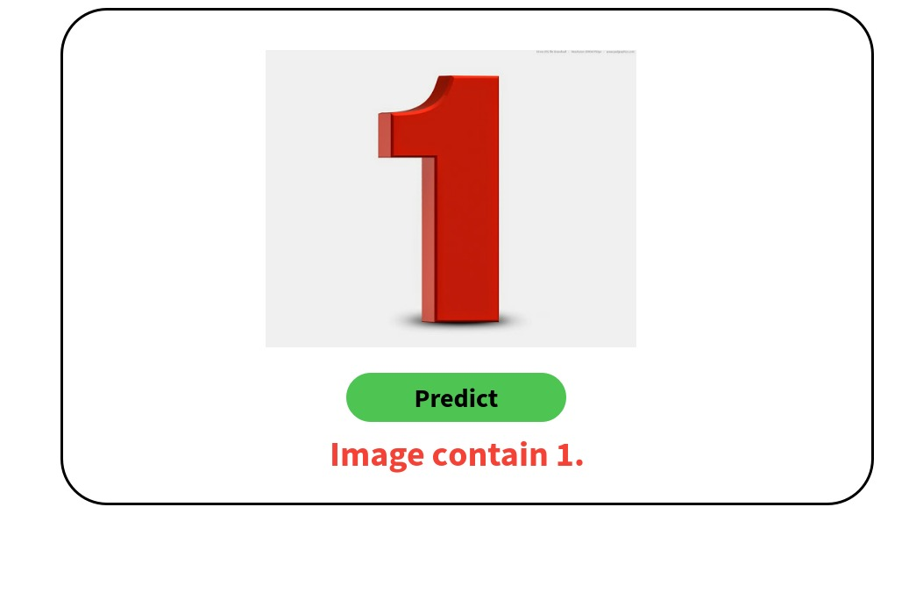

Sample screenshot of project

**4.2 Flask Framework:**



Flask is a micro web framework written in Python. It is classified as a microframework because it does not require particular tools or libraries. It has no database abstraction layer, form validation, or any other components where pre-existing third-party libraries provide common functions.

Benefits:

* built-in development server and fast debugger
* RESTful request dispatching
* [Jinja2](https://quintagroup.com/cms/python/jinja2) templating
* support for secure cookies (client side sessions)
* HTTP request handling function
* Flask has a modular design and lightweight so that it can easy to transit into web framework with some extension
* Basic fundamental API is nicely shaped and coherent
* Highly flexible
* It is easy to deploy the flask in production.

## 4.3 Bidirectional LSTM:

Bidirectional LSTMs are an extension of traditional LSTMs that can improve model performance on sequence classification problems.In problems where all timesteps of the input sequence are available, Bidirectional LSTMs train two instead of one LSTMs on the input sequence. The first on the input sequence as-is and the second on a reversed copy of the input sequence. This can provide additional context to the network and result in faster and even fuller learning on the problem.

This approach has been used to great effect with Long Short-Term Memory (LSTM) Recurrent Neural Networks.

The use of providing the sequence bi-directionally was initially justified in the domain of speech recognition because there is evidence that the context of the whole utterance is used to interpret what is being said rather than a linear interpretation.

The idea of Bidirectional Recurrent Neural Networks (RNNs) is straightforward.

It involves duplicating the first recurrent layer in the network so that there are now two layers side-by-side, then providing the input sequence as-is as input to the first layer and providing a reversed copy of the input sequence to the second.

Using bidirectional will run your inputs in two ways, one from past to future and one from future to past and what differs this approach from unidirectional is that in the LSTM that runs backward you preserve information from the future and using the two hidden states combined you are able in any point in time to preserve information from both past and future.

Chapter 5

# REQUIREMENTS AND ANALYSIS

## 5.1Problem Definition

It is easy for the human to perform a task accurately by practicing it repeatedly and memorizing it for the next time. Human brain can process and analyse images easily. Also, recognize the different elements present in the images. The challenge in handwritten digit recognition are mainly caused by the writing style variations of every single individual. So, it is not easy for the machine to recognize the handwritten digits accurately like the humans do. Hence, robust feature extraction is very important to improve the performance of machines. The problem statement is to classify handwritten digits. The goal is to take an image of a handwritten digit and determine what that digit is. The digits range from zero (0) through nine (9).

## 5.2 Requirements Specification

For implementation, in software we will require the following software and hardware spec- ifications:

**•Software Specification**

For implementation we will require applications such as Anaconda, Scikit learn, Jupiter Notebook etc. That can be used to build an environment based on neural networks and to train machines based on it.

**• Hardware Specification**

To implement the project we will require a computer with specifications such as multi- core CPU, graphics card, hard disk upto 500GB, upto 8GB RAM. Input devices such as keyboard, optical mouse. Output device: LCD monitor.

Chapter 6

Result

## 6.1 Output

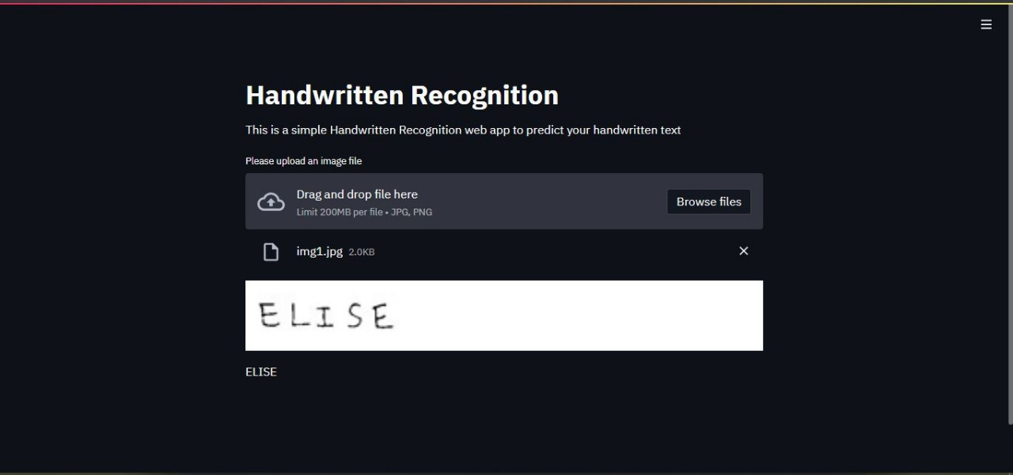

## 

## 6.2 Conclusion

After researching through various papers related to Handwriting digit recognition. We have concluded that a system can be developed that can automatically recognize digits from any handwriting based on their visual aspects. Various experiments had been conducted using different methodologies, the best results are seen in the methods that are based on convolutional neural networks. Hence looking at the results, we have decided to take the same approach for developing our system. We will test our system against benchmark datasets and compare our results based on accuracy, error, and efficiency of the system.

# Bibliography

## Journals and Conferences

[1] N. Das, A. F. Mollah, S. Saha, and S. S. Haque, “Handwritten

arabic numeral recognition using a multi layer perceptron,” CoRR, vol.

abs/1003.1891, 2010. [Online]. Available: http://arxiv.org/abs/1003.1891

[2] “Summary by language size — ehtnologue,”

https://www.ethnologue.com/statistics/size, accessed: 2016-12-25.

[3] “Languages spoken in each country of the world,”

http://www.infoplease.com/ipa/A0855611.html, accessed: 2016-12-25.

[4] “Official languages — united nations,”

http://www.un.org/en/sections/about-un/official-languages/, accessed:2016-12-25.

[5] S. Mori, C. Y. Suen, and K. Yammamoto, “historical review of OCR research and development,”

Proc. IEEE, vol. 80, no. 7, pp. 1029-1058, 1992.

[6] A. Rajavelu, M. T. Musavi, and M. V. Shirvaikar, “A neural network approach to character

recognition,” neural network, vol. 2, no. 5, pp. 387-393, 1989.

[7] H. Byun and S. W. Lee, “Applications of support vector machines for pattern recognition: A

survey,” in pattern recognition with support vector machine, springer, 2002, pp. 213-236.

[8] P. D. Gader, M. Mohamed, and J. H. Chiang, “Handwritten word recognition with character and

inter-charcter neural networks,” IEEE Trans. Syst. Man Cybern. Part B Cybern., vol. 27, no. 1, pp.

158 -164, 1997.

[9] Y. LeCun, Y. Bengio, and G. Hinton, “Deep learning,” nature, vol.521, no.7553, pp. 436-444, 2015.

[10] Kégl Balázs, and Róbert Busa-Fekete, “Boost ing products of base

classifiers,” Proceedings of the 26th Annual International Conference on

Machine Learning, pp.497-504. 2013.

## Websites

https : //skymind.ai/wiki/neural − network

https : //skymind.ai/wiki/convolutional − network

https : //blog.algorithmia.com/introduction − to − computer − vision/

https : //ieeexplore.ieee.org/Xplore/home.jsp

https : //sci − hub.tw/